Day in the Life of the Hudson River 10/14/21
Francis Lewis Park
RIVER MILE: 13.7 (East River)
Salt Front: ~ 49
Mirela Shpuza & International High School for Health Sciences
New York City Park Rangers
55 students & 5 adults
Latitude 40.797289 N & Longitude -73.826217 W
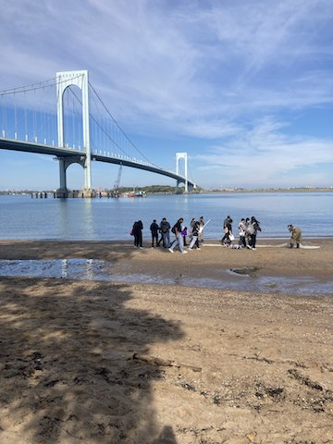 | 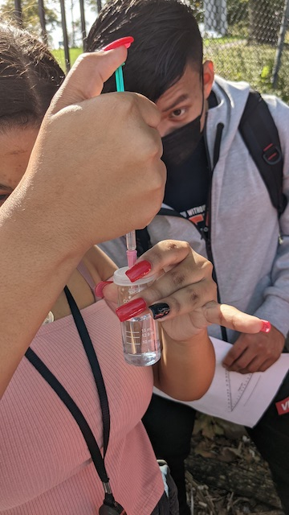 | 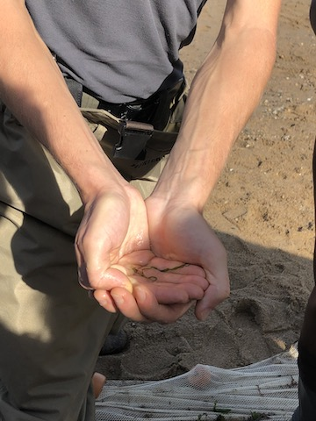 | 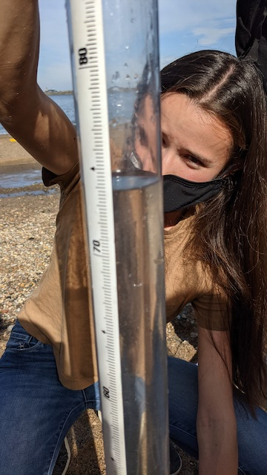

Location: Francis Lewis Park, Queens, NY
Area: Forested and grassy near site; pier
Surrounding Land Use: Forested; Beach
Sampling Site: Park area
Shoreline: Sandy, rocky, beach
Plants in area: none
River Bottom: Muddy
*NR = Not read/recorded
ITEM |  | Time |  | Reading |  |  |  | Comments
Physical
Air Temperature |  | 10:50 AM |  | 26.5 º C |  |  | 80 º F
Wind Speed: |  | 10:54 AM |  | Anemometer  2 m/s |  |  | Beaufort  NR | Direction  NR
Weather today |  | 10:50 AM |  | <25% cloud cover |  |  | No rain
Weather the past 3 days: |  | No rain, nice, Mon. through Wed. partly cloudy
Tides- NR |  | Time |  | Rising, Falling, Unchanged |  |  | Height (cm)
Current- NR |  | Time |  | Cm/sec |  | Knots | North/South | Ebb/Flood/Slack
Water Temperature- |  | 10:55 AM |  | 22º C |  |  | 72 º F
Turbidity- Long Sight Tube |  | 10:45 AM |  | 46 cm |  |  | Tube records NTU as well – 12 NTU
Chemical
Salinity- Hydrometer |  | 10:55 AM |  | 25 ppt
Standardized Salinity-NR
DO – Lamotte Drop Count Kit |  | Time |  | Temp |  |  | ppm DO | % Saturation
 |  | 10:55 AM |  | 22 º C |  |  | 4 | 45%
pH – Color Match Kit |  | 10:55 AM |  | 8.5
Nitrates- NR
Phosphates- |  | 10:55 AM |  | 0.25-0.5 mg/L
Biological
Fish - |  | Number |  | Name |  |  | Length of longest | Length of smallest
 |  | 56  1 |  | Atlantic Silverside  Northern Pipefish |  |  | 10 cm  12 cm | 3.5 cm
Fish Totals |  | TOTAL: 57 |  | Diversity: 2
Macroinvertebrates |  | Number |  | Name |  |  | Length of longest | Length of smallest
 |  | 1 |  | Palaemonetes Shrimp |  |  | NR | NR
Macroinvertebrate Totals |  | TOTAL: 1 |  | Diversity: 1
Sediment Core -NR
Length | H2S smell |  | Oxid Top |  | Oil |  | Grain Size | Other Features
Boats-NR
 | Time |  | Name |  | Color |  | North/Southbound | Light/Loaded
Commercial
Residential

